NATIONAL INSTITUTE OF TECHNOLOGY KARNATAKA SURATHKAL
DEPARTMENT OF INFORMATION TECHNOLOGY
IT 301 Parallel Computing LAB 2
3rd August 2021
Faculty: Dr. Geetha V
---------------------------------------------------------------------------------------------------------------------
NAME: BHUVANESWAR DHARMASIVAM
ROLL NO:191IT107
1. Program 1 [2 Marks]
Aim: To understand and analyze shared clause in parallel directive.
Execute the program and write your observation. Change number of threads and write your observation.
/*shared.c*/
#include<omp.h>
int main()
{
int x=20;
#pragma omp parallel shared(x)
{int tid=omp_get_thread_num();
x=x+1;
printf(“Thread [%d]\n value of x is %d”,tid,x);}
}
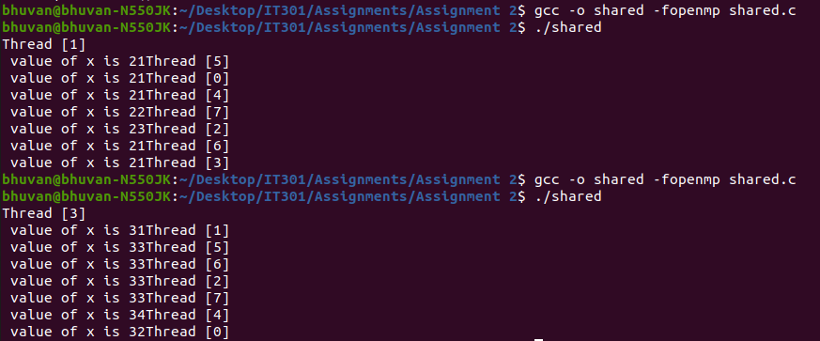
No of threads=20,30.
Explanation: The variable ‘x’ is shared so the change in one threads visible in other threads.
2. Program 2 [2 Marks]
Learn the concept of private(), firstprivate()
(a) First execute the program with declaring i as private(i). Along with results , write your observation
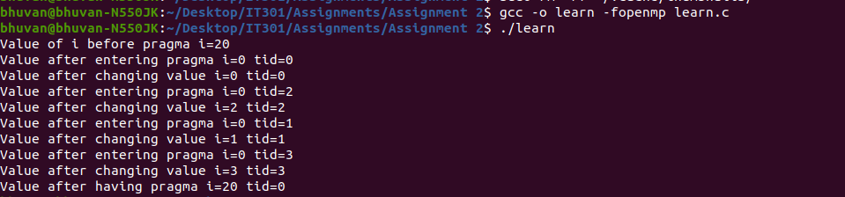
Explanation: The variable ‘i’ is private. It is 20 before parallel region but is not 20 after entering because it is private.

(b) Then execute the same program with firstprivate(i). Observe the results and write your observation.

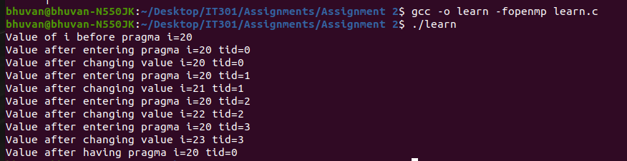
Explanation: ‘i’ is firstprivate so the value before parallel region is assigned to it in the amin thread.

/*learn.c*/
#include<stdio.h>
#include<omp.h>
int main()
{
int i=20;
printf("Value of i before pragma i=%d\n",i);
#pragma omp parallel num_threads(4) private(i)
{
printf("Value after entering pragma i=%d tid=%d\n",i, omp_get_thread_num());
i=i+omp_get_thread_num(); //adds thread_id to i
printf("Value after changing value i=%d tid=%d\n",i, omp_get_thread_num());
}
printf("Value after having pragma i=%d tid=%d\n",i, omp_get_thread_num());}
3. Programming exercise [6 Marks]
Write a parallel program to perform c[i]=a[i]+b[i] where i=0,1,2……N. Execute the program by varying number of elements and number of threads. Check the computation done by each thread.
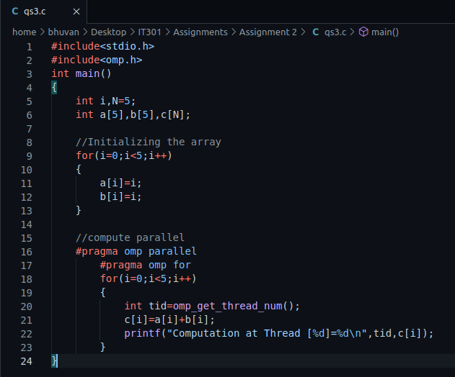
CODE:
EXECUTION:
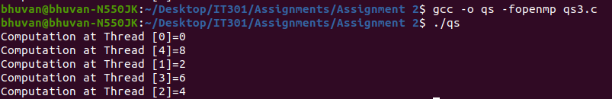
Explanation: The loop construct iterates and executes computation done in each thread.

